2.1 Vector-Valued Functions

- Find the domain of the following vector functions.
- .

- Find any three different parameterizations of the graph on the interval .

- Find any three different parameterization of the graph of on the interval

- Find any three different parameterization for a single tracing of the graph of .

- Match the parametric equations with the graphs below. Give reasons for your choices.
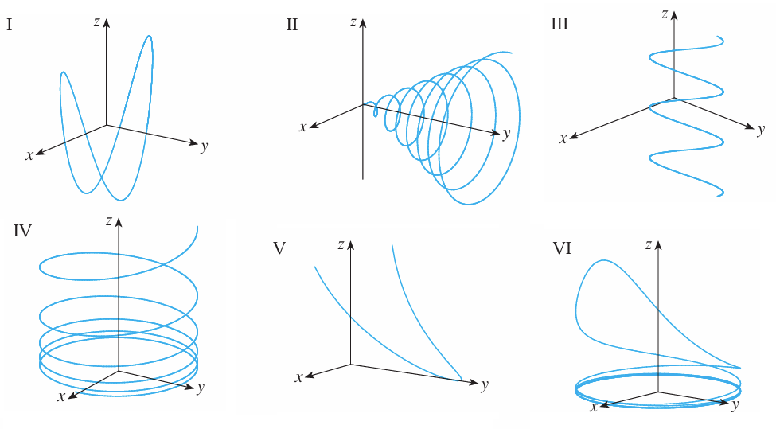

- for .

- for .

- True or False: The functions and generate the same curve.

- Sketch the curve with the given vector equation. Indicate with an arrow the direction in which t increases.

